**MEASURING THE PULSE OF PROSPERITY: AN INDEX OF ECONOMIC FREEDOM ANALYSIS**

**PROJECT REPORT**

1. **INTRODUCTION**:

An index of economic freedom is **a composite measure of the quality of political economic institutions across different jurisdiction.**

1.1**Overview**

Scores and ranks in an index are based on criteria that the creators of the index judge as being relevant which vary from one index to another.

**1.2PURPOSE:**

An index of economic freedom **compares the jurisdiction against each other for various aspects such as traded freedom judicial effectiveness and tax burden**. These factors may be weighed for their influence on economic freedom and collated into a single score for ranking.

**2.PROBLEM DEFINITION AND DESIGN THINKING:**

**2.1 EMPATHY MAP**

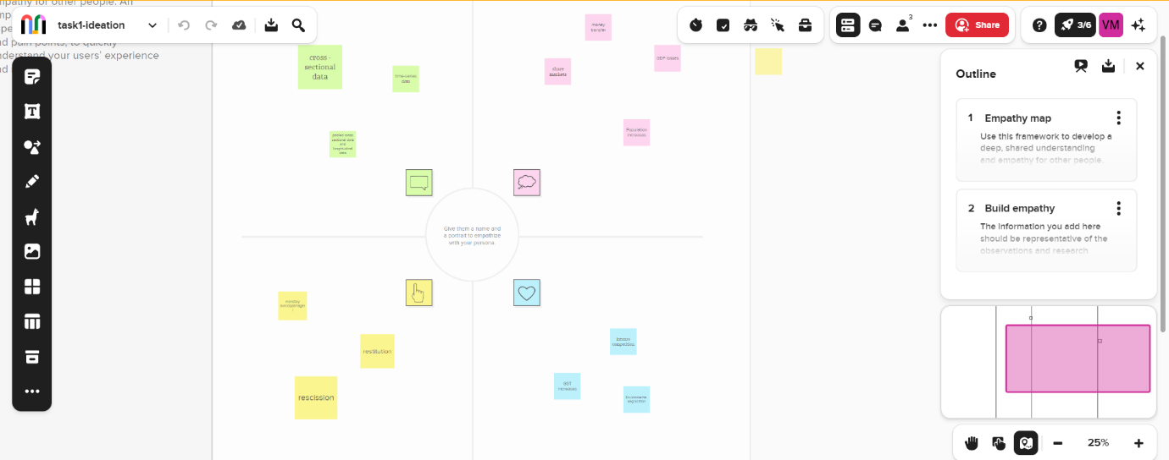

**2.2Ideaton and brainstorming**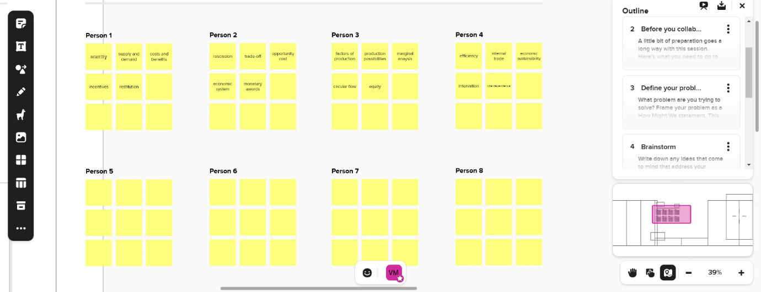

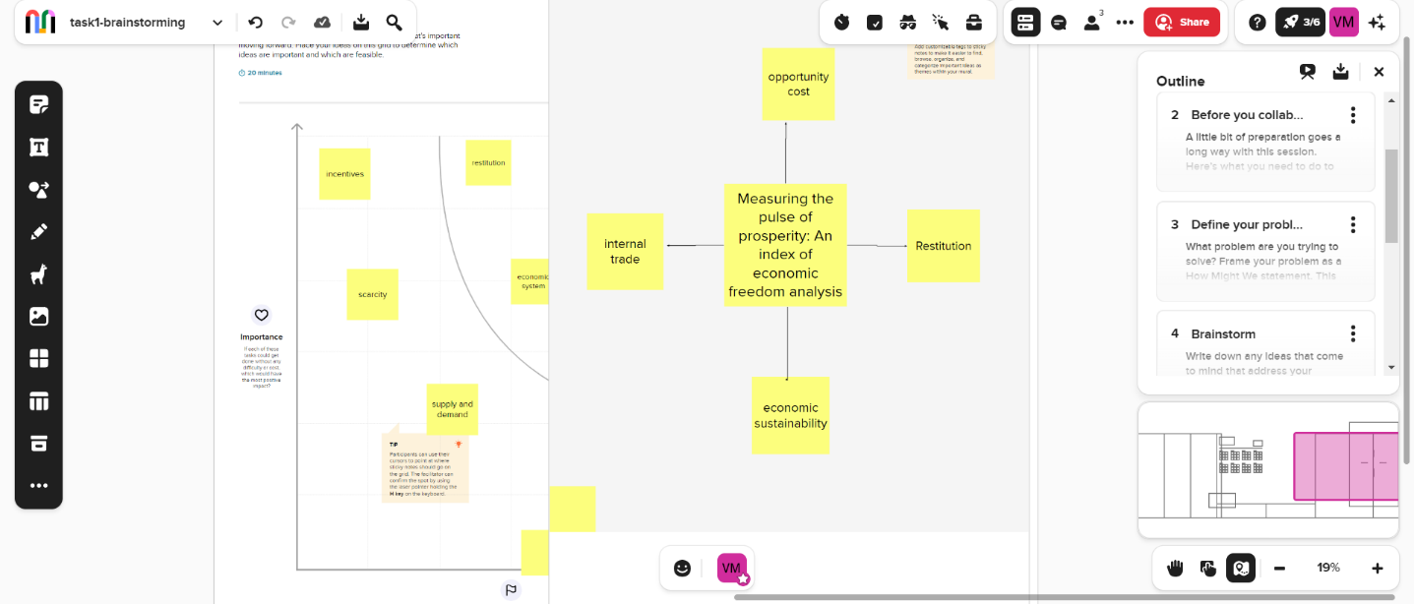

**3.RESULT:**

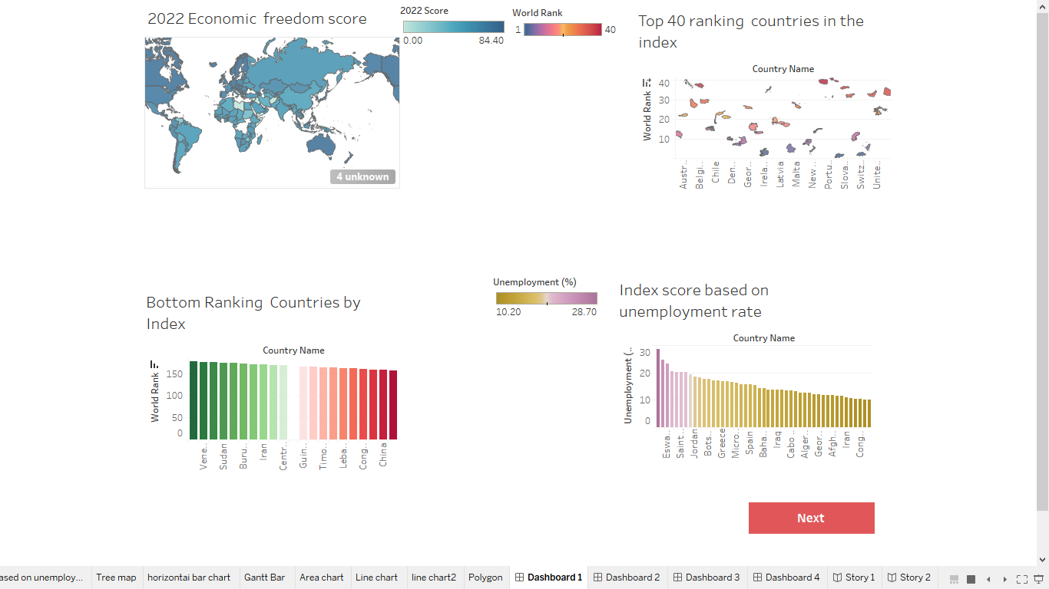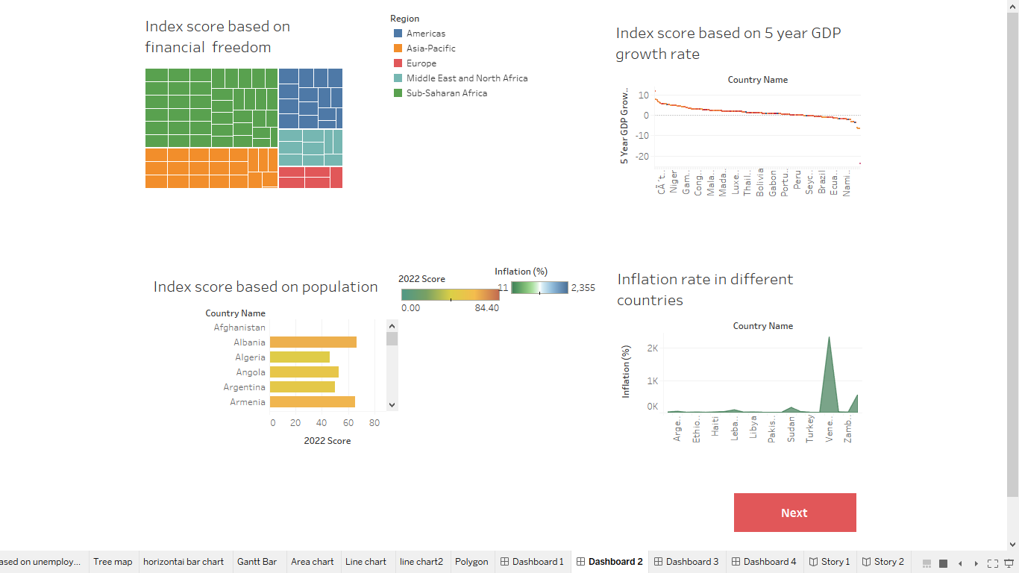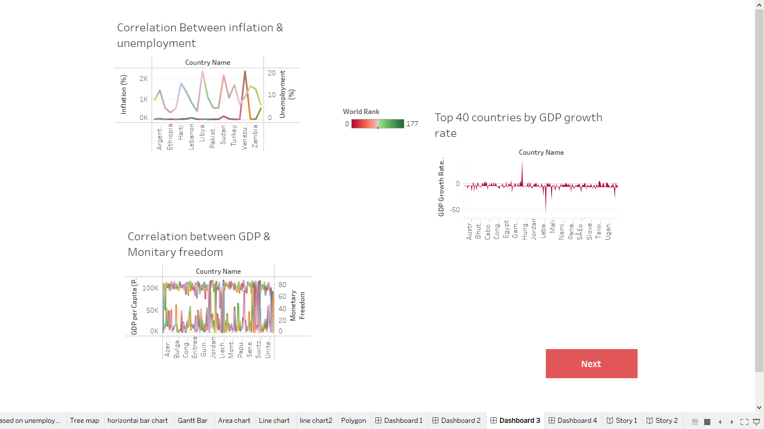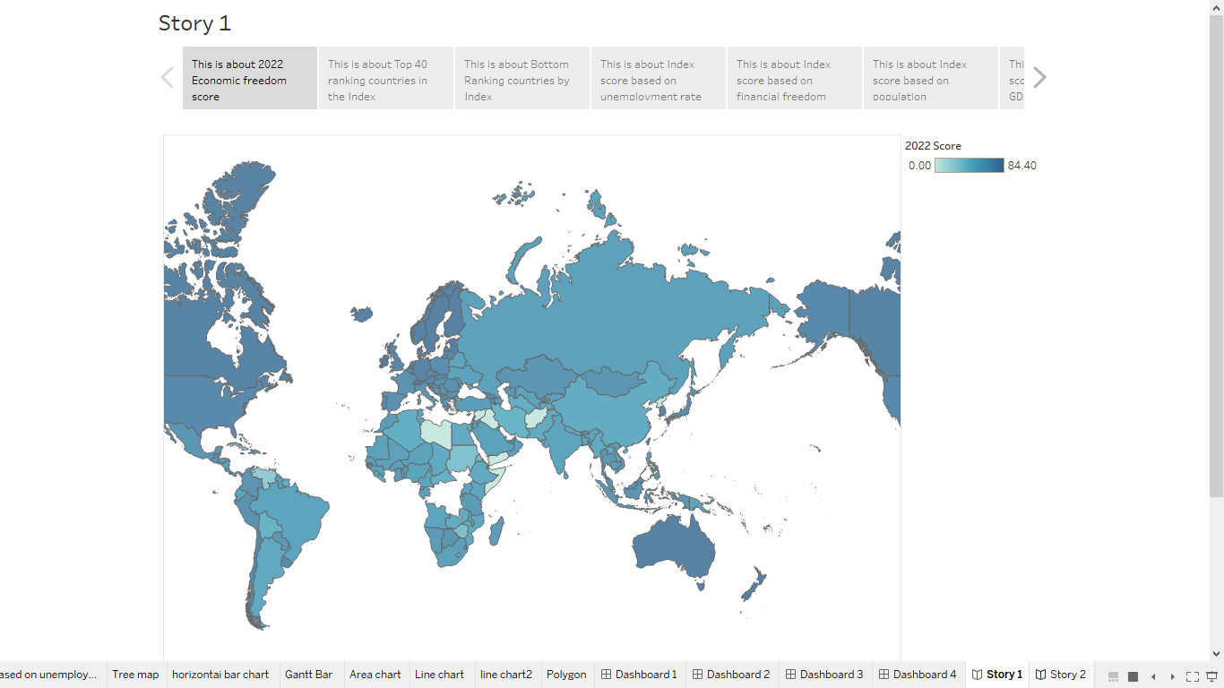

**4.Advantages & disadvantages**

**Advantages**

* + It is the most conductive to widespread prosperity.
  + Spurred innovation in health care, education and other so-called social goods.

**Disadvantages**

* Goods and services that are not profitable will not be produced or run.
* Excessive Merits power of firms.
* Unemployment and inequality.

**5.APPLICATIONS**

* Personal choice.
* Protection of persons and their property from aggression by others.

**6.CONCLUSION**

All economic systems are designed to manage the production, consumption, and distribution of goods and services, they simple have varying degrees of control along the economic spectrum.

**7.FUTURE SCOPE**

Growth in advanced economics is expected to decline from 5% in 2024 to 3.8% while moderating will be sufficient to restore output and investment to their pre-pandemic trend in this economics.

**8. APPENDIX**

**A. Source code:** Vennila team final project.html